Analysing Film texts – Warhorse (2011)

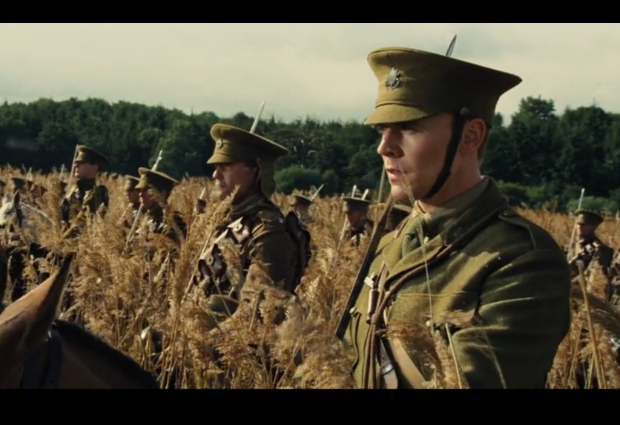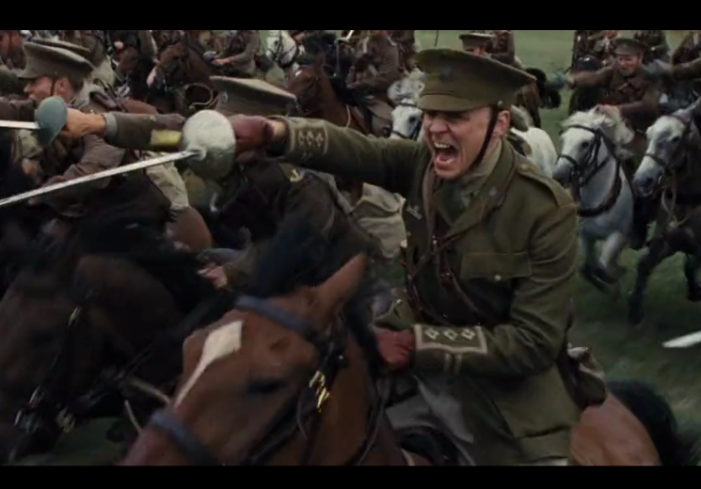

The attack of the English light infrantry is a moment of great anticipation & surprise. With refrence to camera, explain how Spielberg used the camera to elicit emotion in the audience.

` 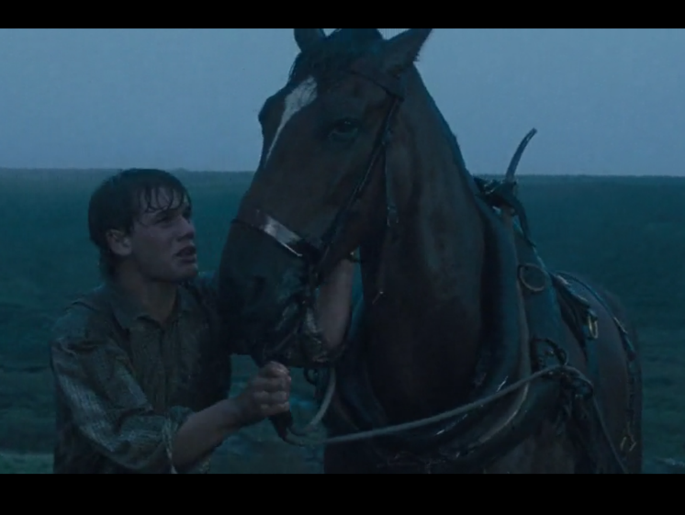 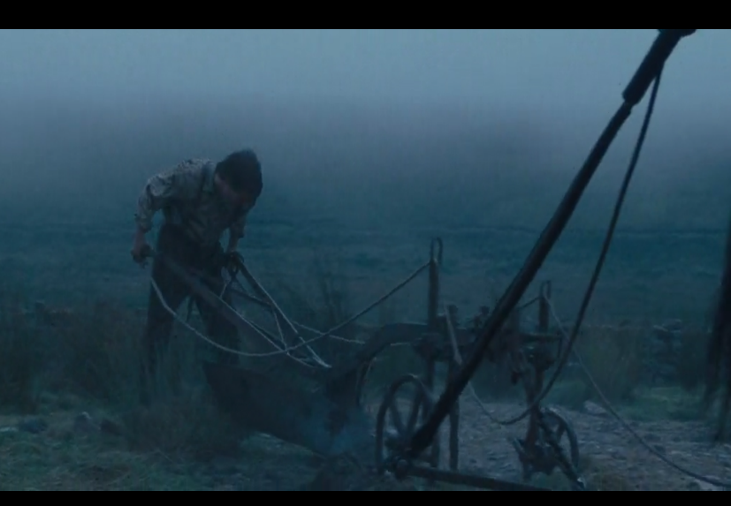

The plow scene with Albert & Joey was a highly emotive moment in the film Warhorse. With reference to acting & sound, explain how Spielberg managed to capture the moment.

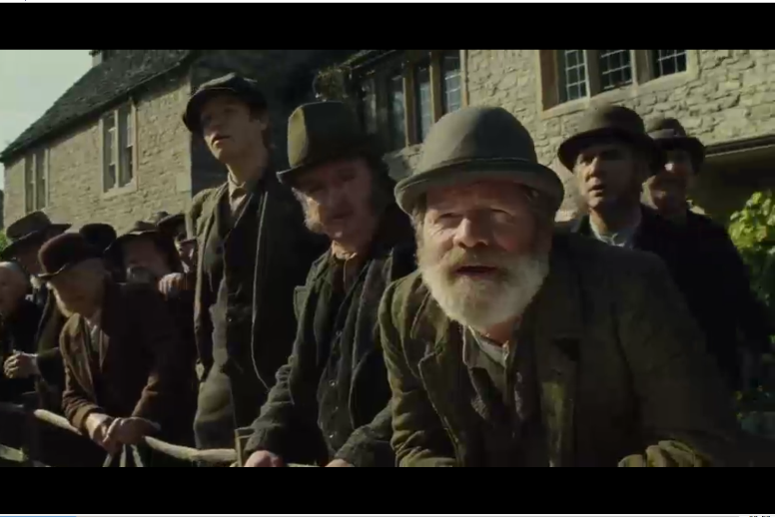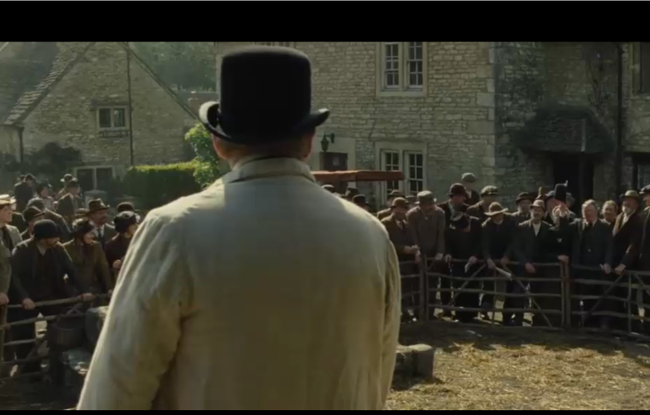

The Saleyard scene involves a tense battle between the landlord & Ted Narracott. Explain how Spielberg created this atmosphere with reference to a technical code & convention of film narratives.

